CHAPTER -Electricity

Q1 An electric generator converts
- Electric Energy into sound energy
- Electric Energy into light energy
- Electric Energy into mechanical energy
- Mechanical Energy into electric energy

Q2 The wire used in the filaments of household bulbs has
- High resistance, high melting point
- High resistance, low melting point
- Low resistance, high melting point
- Low resistance, Low melting point
Q3 The device that changes the voltage of an electric power supply is
- Potentiometer
- Transformer
- Voltmeter
- battery

Q4 The heating element of an electric iron is made of
- iron
- tungsten
- nichrome
- copper

Q5 A tube light works on the principle of
- chemical effect of current
- magnetic effect of current
- heating effect of current
- discharge of electrons through gases
Q6 The work done in moving a unit positive charge across two points in an electric circuit is the measure of
- potential difference
- electrostatic force
- current
- power
Q7 In electric supply lines in india ,which parameter is kept constant[CDS 2007]
- Voltage
- Current
- Frequency
- Power

Q8 The main power supply in india is at 220 V ,whereas that in the US is at 110 V .Which among the following statement is correct [NDA- 2012]
- 110 V is safer but more expensive to maintain
- 110 V is safer but more cheaper to maintain
- 110 V leads to lower power loss
- 110 works better at higher latitudes
Q9 The resistance of a wire of length l and area of cross section a is x ohm.If the wire is stretched to double its length ,its resistance would become [NDA-2015]
- 2x ohm
- 0.5xohm
- 4xohm
- 6xohm
Q10 A given conductor carrying a current I ampere .It produces an amount of heat equal to 2000J .The current through the conductor is double the amount of heat produced will be [NDA-2016]

- 2000J
- 4000J
- 8000J
- 1000J

Q11 A simple circuit contains a 12 V battery and a bulb having 24 ohm resistance .When turn on the switch the ammeter connected to the circuit would read [NDA 2016]
- 0.5 A
- 2A
- 4A
- 5A

Q12 Three resistors with magnitudes 2 ohm,4ohm and 8 ohm are connected to parallel, equivalent resistance of the system would be [NDA 2016]
- Less than 2 ohm
- More than 2 ohm but less than 4 ohm
- 4ohm
- 14 ohm

Q13 If a free electron moves through a potential difference of 1 Kv,then the energy gained by the electron is given by[NDA 2018]
- 1.6x10⁻¹⁹J
- 1.6x10⁻¹⁶J
- 1x10⁻¹⁹J
- 1x10⁻¹⁶J

Q14 Consider the following circuit
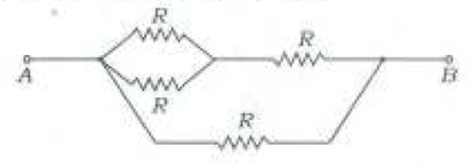
Which is the effective resistance between A and B[NDA2018]
- 2R/5
- 3R/5
- 3R/2
- 4R
Q15 The graphs between current (I) and Voltage (V) for three linear resistors 1,2 and 3 are given below
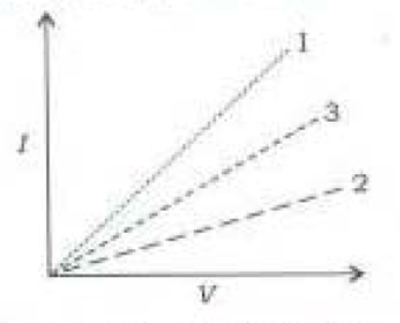
If R1 ,R2 and R3 are the resistances of these resistors ,then which of the following is correct[NDA 2018]
- R1>R2>R3
- R1<R3<R2
- R3<R1<R2
- R3>R2>R1
Q16 The unit of resistivity is
(a) ohm
(b) ohm meter
(c) ohm metre⁻¹
(d) mho metre⁻¹

Q17 A wire of resistance R is cut into n equal parts. These parts are then connected in parallel. The equivalent resistance of combination will be :
- nR
- R/n
- n/R
- R/n²

Q18 Three resistance each of 8Ω are connected to a triangle. The resistance between any two terminal will be:
- 12ohm
- 24ohm
- 2ohm
- 16/3ohm

Q19 In how many parts(equal) a wire of 100Ω be cut so that a resistance of 1Ω is obtained by connecting them in parallel ?
- 10
- 100
- 20
- 50
Q20 The filament of an electric bulb is made of tungsten because :
- its resistance is negligible
- it is cheaper
- its melting point is high
- its filament is easily made

Q21 In the given circuit, the effective resistance between points A and C will be :
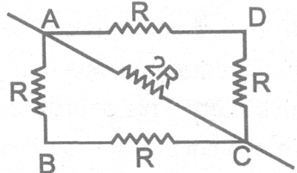
- 3R
- 3R/2
- 2R/3
- None of these

Q22 A fuse wire is always connected to the :
- neutral wire
- earth wire
- live wire
- none of these

Q23 The wire having a red plastic covering is a :
- live wire
- neutral wire
- earth wire
- none of these

Q24 A switch is always connected to the
- earth wire
- neutral wire
- live wire
- none of these

Q25 High power electrical appliances are earthed to
- avoid shock
- avoid wastage
- Make the appliance look beautiful
- reduce the bill

Q26 If the current I through a resistor is increased by 100% the increased in power dissipation will be (assume temperature remain unchanged)
(a) 100%
(b) 200%
(c) 300%
(d) 400%

Q27 An electric bulb is rated 220 V and 100 W. When it is operated on 110 V, the power
consumed will be:
(a) 100 W
(b) 75 W
(c) 50 W
(d) 25 W

Q28 Find the current flowing through 3 Ω .

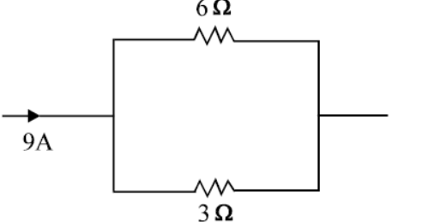
- 3 Ω
- 6 Ω
- 9 Ω
- 12 Ω
Q29 Find the equivalent resistance across A & B.
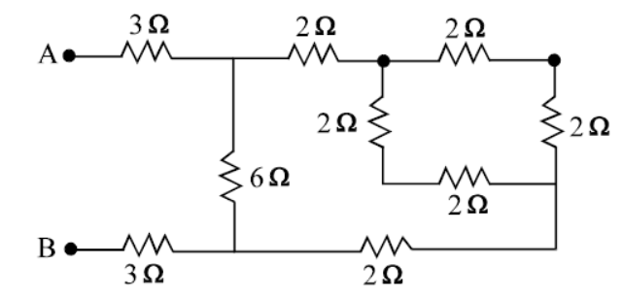
- 3 Ω
- 6 Ω
- 9 Ω
- 12 Ω

Q30 A 3 volt battery with negligible internal
resistance is connected in a circuit as shown
in the figure. The current I, in the circuit
will be

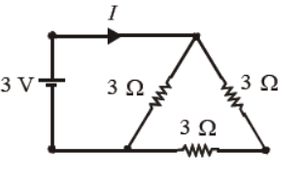

(a) 1 A
(b) 1.5 A
(c) 2 A
(d) (1/3) A

Q1 | Q2 | Q3 | Q4 | Q5
Q6 | Q7 | Q8 | Q9 | Q10
Q11 | Q12 | Q13 | Q14 | Q15
Q16 | Q17 | Q18 | Q19 | Q20
Q21 | Q22 | Q23 | Q24 | Q25
Q26 | Q27 | Q28 | Q29 | Q30

